**AZERBAIJAN STATE OIL INDUSTRY UNIVERSITY**

**CALCULUS INDEPENDENT WORK**

**STUDENT:GUNEL HUMBATOVA**

**GROUP:604.20E**

1. Find the distance between the two lines:  and .

*Solution:*

First we should find slopes.

🡪 The lines are parallel.

$c_{1}=-0.25 c_{2}=-2.5$

Distance between two parallel lines:

$\left|c_{1}-c_{2}\right|= \left|-0.25+2.5\right|= \left|2.25\right|=2.25$

Answer:2.25

**2.** A rancher plans to fence a rectangular pasture adjacent to a river. The rancher has 100 meters of fencing, and no fencing is needed along the river (see figure).

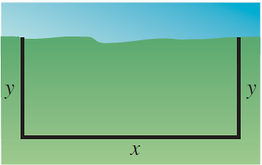

Write the area  of the pasture as a function of , the length of the side parallel to the river. What is the domain of ?

*Solution:*

If one side of rectangle is x and other side is y, then circumference is c=2(x+y).

One side of rectangular pasture is next to river,and this side is x.Then whole length is:x+2y

Given length of fence is:100 meter

x+2y=100 🡪 y = $\frac{100-x}{2}$

Area is:xy Then A= $x∙\frac{100-x}{2}$

A(x) = 🡪

Because area must be a positive value, we can conclude that A>0.

A>0 🡪

So, the domain of A is (0;100)

3.Graph the parabolas and find their points of intersection. Find an equation of the line through the points of their intersection:  and .

$x^{2}=4x-x^{2}$

$2x^{2}-4x=0$

$2x\left(x-2\right)=0$

$x_{1}=0 x_{2}=2$

$y_{1}=0 y_{2}=4$ (0;0) (2;4)

$m=\frac{4-0}{2-0}=2$

Equation of the line through the points of their intersections:

$y=2x$

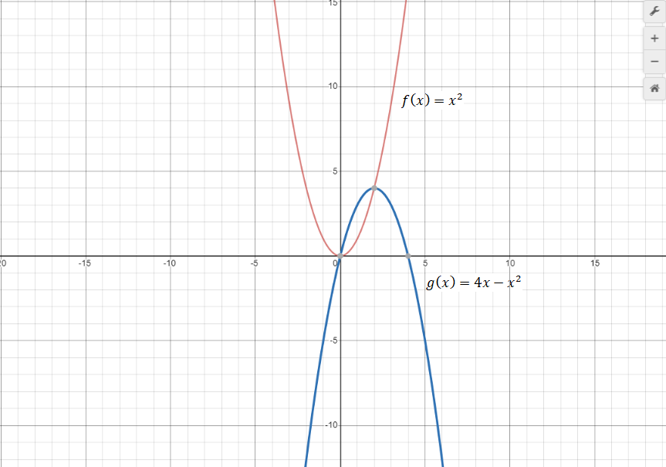

**4**. Find the distance between the points  and  along the line .

*Solution:*

$$1=4\left(1\right)-3$$

$$9=4\left(3\right)-3$$

Points are on the same line:

The distance between the points is:

$$\sqrt{{\left(3-1\right)}^{2}+{\left(9-1\right)}^{2}}=\sqrt{4+64}=\sqrt{68}$$

Answer: $\sqrt{68}$

**5**. Find an equation of the line that passes through the point  and has the slope  undefined.

*Solution*:

Formula of slope is: $m=\frac{∆y}{∆x}$

Undefined slope means that slope = infinity or negative infinity or a vertical line.

A vertical line means that **x** coordinate never changes.

So, $x=-5$

There is no **y** intercept.The line never crosses the **y** axis.

**y** is any value.

Then the equation is: $x=-5$.

***6.Proof $\frac{d }{dx} \left[sinx\right]=cos⁡(x)$***

$\lim_{x→0}{\frac{sinx}{x}}=1$ $\lim_{x→0}{\begin{aligned}\frac{cosx-1}{x}\end{aligned}=0}$

$\frac{d}{dx}f(x)=\lim_{h→0}{\begin{aligned}\frac{f\left(x+h\right)-f(x)}{h}\end{aligned}}$

$\lim_{h→0}{\begin{aligned}\frac{\sin\left(x+h\right)-sinx}{h}\end{aligned}}$

$\lim_{h→0}{\frac{sinx∙cosh+sinh∙cosx-sinx}{h}}$

$\lim_{h→0}{\frac{sinx\left(cosh-1\right)+sinh∙cosx}{h}}$

$\lim_{h→0}{\frac{sinx\left(cosh-1\right)}{h}+\lim_{h→0}{\frac{sinhcosx}{h}=0+cosx=cosx}}$

***Proof $\frac{d}{dx}\left[cosx\right]= -sin⁡(x)$***

$f^{'}\left(x\right)=\lim_{h→0}{\frac{f\left(x+h\right)-f(x)}{h}}$

$cos^{'}\left(x\right)=\lim_{h→0}{\frac{\cos\left(x+h\right)-cos⁡(x)}{h}}$

$=\lim_{h→0}{\frac{[cos\left(x\right)\cos\left(h\right)-\sin\left(x\right)sin⁡(h)]-cos⁡(x)}{h}}$

$=\lim_{h→0}{\frac{\cos\left(x\right)\left[\cos\left(h\right)-1\right]-\sin\left(x\right)\sin\left(h\right)}{h}}$

$=\lim_{h→0}{\cos\left(x\right)\left[\frac{\cos\left(h\right)-1}{h}\right]-\sin\left(x\right)[\frac{sin⁡(h)}{h}}]$

$=\lim_{h→0}{cos⁡(x)∙0}-\sin\left(x\right)∙1= -sin⁡(x)$

***7.Proof $\frac{d}{dx}\left[c\right]=0$***

Let $f\left(x\right)=c.$

$f^{'}\left(x\right)= \lim_{h→0}{\frac{f\left(x+h\right)-f\left(x\right)}{h}}$

$=\lim_{h→0}{\frac{c-c}{h}}$

$=\lim_{h→0}{\frac{0}{h}}= \lim_{h→0}{0}=0$

***8.Proof $\frac{d}{dx}\left[x^{n}\right]=n∙x^{n-1}$***

$\frac{d}{dx}\left[x^{n}\right]=n∙x^{n-1}$, $n∈Z^{+}, f\left(x\right)=x^{n}$

$\lim_{∆x→0}{\frac{{\left(x+∆x\right)}^{n }-x^{n}}{x∆}}$

$=\lim_{∆x→0}{\frac{\left(x+x∆\right)\left(x+x∆\right)\left(x+x∆\right)…\left(x+x∆\right)-x^{n}}{x∆}}$

= $\lim_{∆x→0}{\frac{x^{n}+n∙x^{n-1}∙ ∆x +{\left(∆x\right)}^{2}\left(…\right)-x^{n}}{x∆}}$

= $\lim_{∆x→0}{n∙x^{n-1}+ ∆x\left(…\right) }$

= $\lim_{∆x→0}{n∙x^{n-1 } + \lim_{∆x→0}{∆x\left(…\right)} }$

= $\lim_{∆x→0}{n∙x^{n-1 } + 0 }$ = $n∙x^{n-1 }$

***9. Proof $\frac{d}{dx}\left[cf\right]=c\frac{d}{dx} \left[ f \right]$***

$\frac{d}{dx}\left[cf\left(x\right)\right]= \lim_{h→0 }{\frac{cf\left(x+h\right)-cf(x)}{h}}$

= $\lim_{h→0}{\frac{c(f\left(x+h\right)-f\left(x\right))}{h}}$

$=c\lim_{h→0}{\frac{f\left(x+h\right)-f(x)}{h}}$

$=c∙f'(x)$

***10. Proof $\frac{d}{dx}\left[f\left(x\right)+g\left(x\right)\right]=\frac{d}{dx}f\left(x\right)+\frac{d}{dx}g\left(x\right)$***

$\frac{d}{dx}\left[f\left(x\right)+g\left(x\right)\right]= \lim_{h→0}{\frac{\left(f\left(x+h\right)+g\left(x+h\right)\right)-f\left(x\right)+g(x))}{h}}$

$=\lim_{h→0}{\frac{f\left(x+h\right)+g(x+h)-f\left(x\right)+g(x)}{h}}$

$=\lim_{h→0}{\frac{f\left(x+h\right)-f\left(x\right)+g\left(x+h\right)-g(x)}{h}}$

$=\lim_{h→0}({\frac{f\left(x+h\right)-f(x)}{h}}+\frac{g\left(x+h\right)-g(x)}{h}$)

$=\lim_{h→0}({\frac{f\left(x+h\right)-f(x)}{h}}+ \lim_{h→0}\frac{g\left(x+h\right)-g(x)}{h}$

$=f^{'}\left(x\right)+g'(x)$

11.Proof

12. Proof

Subtract and add: $f\left(x+h\right)g(x)$

$$=\lim_{h→0}{\frac{f\left(x+h\right)g\left(x+h\right)-f\left(x+h\right)g\left(x\right)+f\left(x+h\right)g\left(x\right)-f\left(x\right)g(x)}{h}}$$

$$=\lim_{h→0}{\frac{f\left(x+h\right)g\left(x+h\right)-f\left(x+h\right)g\left(x\right)}{h}}+ \lim_{h→0}{\frac{f\left(x+h\right)g\left(x\right)-f\left(x\right)g\left(x\right)}{h}}=$$

$$=\lim_{h→0}{f\left(x+h\right)\frac{g\left(x+h\right)-g(x)}{h}+\lim_{h→0}{g\left(x\right)\frac{f\left(x+h\right)-f(x)}{h}}}$$

$$=f\left(x\right)∙\lim_{h→0}{\frac{g\left(x+h\right)-g\left(x\right)}{ h}+g\left(x\right)∙}\lim_{h→0}{\frac{f\left(x+h\right)-f\left(x\right)}{h}}$$

$$=f\left(x\right)∙g^{'}\left(x\right)+g(x)∙f^{'}(x)$$

13.Proof $\frac{d}{dx}[f\left(g\left(x\right)\right)]$

$$\frac{d}{dx}\left[f\left(g\left(x\right)\right)\right]= \lim_{h→0}{\frac{f(g\left(x+h\right)-f(g\left(x\right))}{h}}$$

$$\frac{d}{dx}\left[f\left(g\left(x\right)\right)\right]= \lim_{h→0}{\frac{f\left(g\left(x+h\right)\right)-f(g\left(x\right))}{\left(x+h\right)-x}}$$

$$\frac{d}{dx}\left[f\left(g\left(x\right)\right)\right]=\lim_{h→0} \left(\frac{f\left(g\left(x+h\right)\right)-f\left(g\left(x\right)\right)}{x} ∙\frac{g\left(x+h\right)-g\left(x\right)}{g\left(x+h\right)-g\left(x\right)}\right)$$

$$\frac{d}{dx}\left[f\left(g\left(x\right)\right)\right]=\underset{h→0}{lim⁡}\left(\frac{f\left(g\left(x+h\right)\right)-f\left(g\left(x\right)\right)}{g\left(x+h\right)-g(x)} ∙\frac{g\left(x+h\right)-g\left(x\right)}{\left(x+h\right)-x}\right)$$

$$\frac{d}{dx}\left[f\left(g\left(x\right)\right)\right]=\underset{h→0}{lim⁡}\left(\frac{f\left(g\left(x+h\right)\right)-f\left(g\left(x\right)\right)}{g\left(x+h\right)-g(x)} \right) ∙ \lim_{h→0}{\frac{g\left(x+h\right)-g(x)}{\left(x+h\right)-x}}$$

$$\frac{d}{dx}\left[f\left(g\left(x\right)\right)\right]=\underset{h→0}{lim⁡}\left(\frac{f\left(g\left(x+h\right)\right)-f\left(g\left(x\right)\right)}{g\left(x+h\right)-g(x)} \right) ∙ \lim_{h→0}{\frac{g\left(x+h\right)-g(x)}{h}}$$

$$\frac{d}{dx}\left[\left(g\left(x\right)\right)\right]=f^{'}\left(g\left(x\right)\right)g^{'}\left(x\right)$$